**NAME** :- Manish Shashikant Jadhav

**UID** :- 2023301005.

**BRANCH** :- Comps -B. **BATCH:** B.

**EXPERIMENT 6: To retrieve a data using subquery, nested query for university database.**

**SUBJECT** :- DBMS (DATABASE MANAGEMENT SYSTEM)

1. Find the course id and title of all courses taught by an instructor named 'Srinivasan'

**Query:**

SELECT c.course_id, c.title FROM

course c JOIN (SELECT b.course_id FROM

teaches b JOIN (SELECT id FROM instructor WHERE name= "Srinivasan")

a WHERE b.id = a.id) x

WHERE c.course_id = x.course_id;

**Output:**

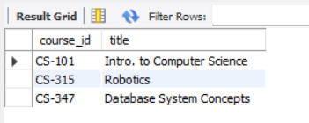

1. Find the total capacity of every building in the university

**Query:**

SELECT building, sum(capacity) AS capacity

FROM classroom

GROUP BY building

**Output:**

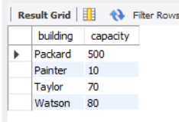

1. Find all departments that have at least one instructor, and list the names of the departments along with the number of instructors; order the result in descending order of number of instructors.

**Query:**

SELECT

d.dept_name, count(*) AS num

FROM

department d

INNER JOIN

instructor i

ON

d.dept_name = i.dept_name

GROUP BY

d.dept_name

ORDER BY num DESC;

**Output:**

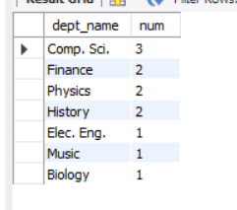

1. For each student, compute the total credits they have successfully completed, i.e. total credits of courses they have taken, for which they have a non-null grade other than 'F'. Do NOT use the tot_creds attribute of student.

**Query:**

SELECT S.ID, S.NAME, SUM(C.CREDITS) AS TOTAL

FROM STUDENT AS S, TAKES AS T, COURSE AS C

WHERE S.ID = T.ID AND T.COURSE_ID = C.COURSE_ID

AND T.GRADE != "F"

GROUP BY S.ID;

**Output:**

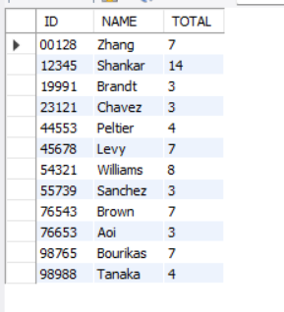

1. Find the number of students who have been taught (at any time) by an instructor named 'Srinivasan'. Make sure you count a student only once even if the student has taken more than one course from Srinivasan.

**Query:**

select sum(c) as count from

(SELECT DISTINCT COUNT(STUDENT.ID) AS C FROM STUDENT

INNER JOIN TAKES ON STUDENT.ID = TAKES.ID

INNER JOIN TEACHES ON TAKES.COURSE_ID = TEACHES.COURSE_ID

INNER JOIN INSTRUCTOR ON INSTRUCTOR.ID = TEACHES.ID

WHERE INSTRUCTOR.NAME = "Srinivasan"

GROUP BY STUDENT.ID) c;

**Output:**

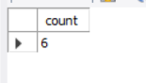

1. Find the name of all instructors who get the highest salary in their department.

**Query:**

SELECT A.NAME FROM

INSTRUCTOR A INNER JOIN

(SELECT DEPT_NAME, MAX(SALARY) AS SALARY

FROM INSTRUCTOR GROUP BY DEPT_NAME) B

ON A.SALARY = B.SALARY;

**Output:**

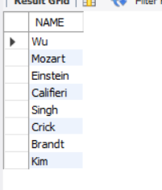

1. Find the total money spent by each department for salaries of instructors of that department.

**Query:**

SELECT D.DEPT_NAME, SUM(I.SALARY) SALARIES FROM INSTRUCTOR I

INNER JOIN DEPARTMENT D

WHERE I.DEPT_NAME = D.DEPT_NAME

GROUP BY D.DEPT_NAME

ORDER BY SALARIES DESC;

**Output:**

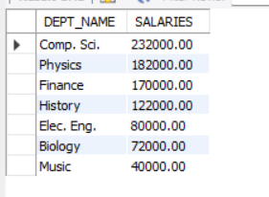

**Conclusion:** Hence by completing this experiment I came to know about how to retrieve a data using subquery, nested query for university database.